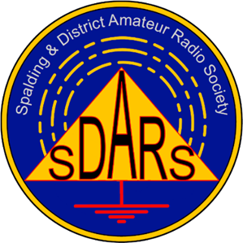
Spalding & District Amateur Radio Society

Radio, Electronics and Computer Rally

To be held at: Spalding Rugby and Football Club
Centenary Park
Drain Bank North
Spalding, Lincs
PE12 6AF

Date: Sunday, 1st June 2025

Contacts: Graham Boor G8NWC 07754 619701

Booking Details
Company Name:

Contact Address:

Telephone Number (Day) (Evening)

Indoor tables are charged at £10.00 per table and includes entry for 1 person.

Number of inside tables required:

Do you require power? (Inside tables only.)

Any other requirements:

I enclose 50% deposit (non-refundable) / full payment of £

Please make cheques payable to “SDARS” and return this completed form and payment to:

SDARS Rally
27 Welbeck drive
Spalding
PE11 1PD

Bank Transfer: Spalding & District Amateur Radio Society
Account 00078290 / Sort code 30-97-95 / Use Rally2025 as ref

The rally will open at 10am and Spalding & District A.R.S. members will be on site from 7am onwards.

We thank you for your kind co-operation and wish you a pleasant and profitable day, a safe journey to and from the venue. We appreciate your support at our rally and are keen to assist you in every way. Should you have any snags or queries on the day, please contact any of the club staff, who will do their best to ease any problems that may occur.

