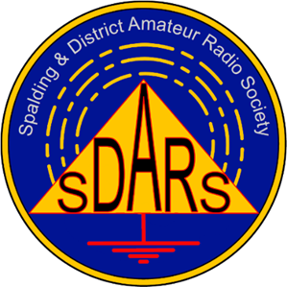
Spalding & District Amateur Radio Society

Radio, Electronics and Computer Rally

To be held at: Holbeach United Youth FC
Pennyhill Road
Holbeach
Lincs
PE12 7PR.

Date: Sunday, 4th June 2023

Contacts: Graham Boor G8NWC 07754 619701
John Hill G4NBR 07946 302815

Booking Details
Company Name:

Contact Address:

Telephone Number (Day) (Evening)

Tables are only available inside (maximum of 20 tables), in multiples of 6ft x 2ft 3ins at a rate of £10.00 per table. There is a discount of 20% for fully prepaid bookings received by the end of April. This price includes admittance for 2 people.

Number of inside tables required:

Do you require power? (Inside tables only.)

Any other requirements:

I enclose 50% deposit (non-refundable) / full payment of £

Please make cheques payable to “SDARS” and return this completed form and payment to:

SDARS Rally
27 Welbeck drive
Spalding
PE11 1PD

Bank Transfer: Spalding & District Amateur Radio Society
Account 00078290 / Sort code 30-97-95 / Use Rally2023 as ref

The rally will open at 10am and Spalding & District A.R.S. members will be on site from 7am onwards.

We thank you for your kind co-operation and wish you a pleasant and profitable day, a safe journey to and from the venue. We appreciate your support at our rally and are keen to assist you in every way. Should you have any snags or queries on the day, please contact any of the club staff, who will do their best to ease any problems that may occur.

